PARALLEL AND DISTRIBUTED COMPUTING REPORT

System/ Test Platform :
VM ware: Ubuntu 16.04
RAM: 4 GB
Memory: 50 GB
Processor: Intel® Core™ i7-6700HQ CPU @ 2.60GHz × 2
OS- type: 64-bit
VM Ware is being run on Windows OS.

Problem 1:

1. Naive multiplication

Execution Time: 1943.48 secs
Performance (MFLOPs/sec): 70.7177 MFLOPs/sec

Number of Runs: 5
The executing time and number of FLOPs obtained is the average number of the 5 runs

2. Block multiplication

The various types of block sizes used are : [4,8,16]

Case 1:

Block size: 4

Execution Time (in sec) : 967.494 sec
Performance (MFLOPs/sec) : 146.722 MFLOPs/sec

Case 2:

Block size: 8

Execution Time (in sec) : 532.381 sec
Performance (MFLOPs/sec) : 258.259 MFLOPs/sec

Case 3:

Block size: 16

Execution Time (in sec) : 465.9166 sec
Performance (MFLOPs/sec) : 295.151 MFLOPS/sec

The above results are averaged over 5 runs
Taking the Execution time and the MFLOPs of the above cases following plots can be drawn.

Plot 1: Execution Time
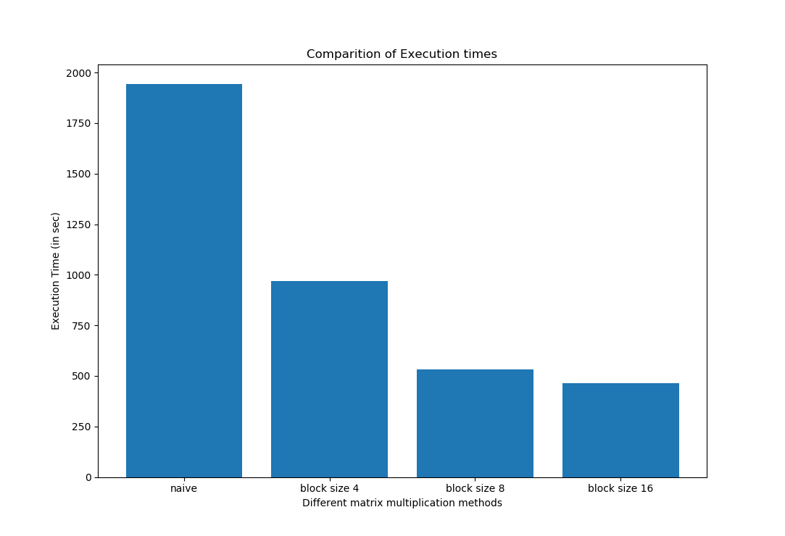

Plot 2: Sustained Performance : MFLOP/sec

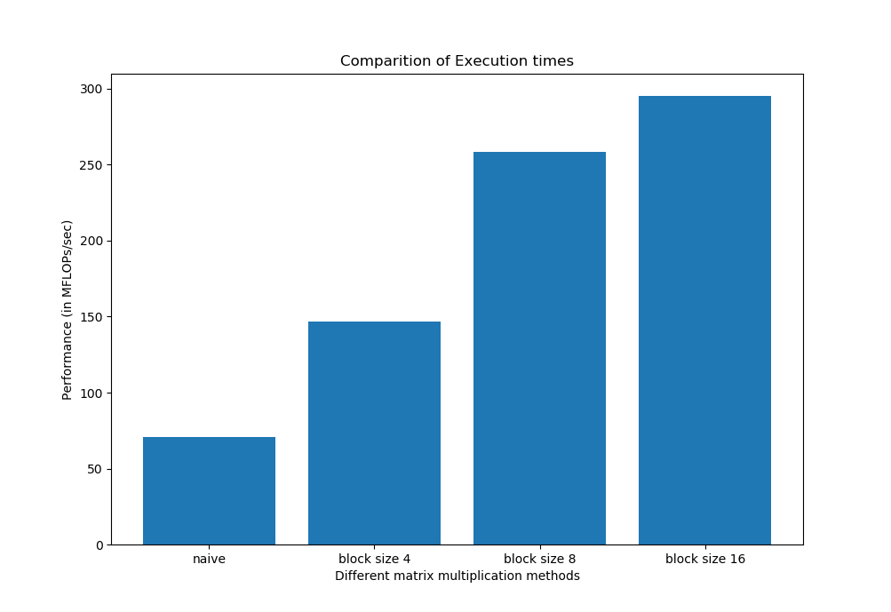

Conclusion :
Although, block matrix multiplication uses 3 more for loops as compared to the naive implementation. we can see that block matrix multiplication is quicker as compared to the naive implementation

Problem 3:

K-means

Execution Time for 30 iterations (in sec): 1.5839 sec

Number of Runs: 10

Iteration time for each run:

1. 1.60046 sec
2. 1.5897 sec
3. 1.57684 sec
4. 1.57162
5. 1.59116 sec
6. 1.5941 sec
7. 1.58138 sec
8. 1.57989 sec
9. 1.5796 sec
10. 1.577 sec

Input/ Output Image:

